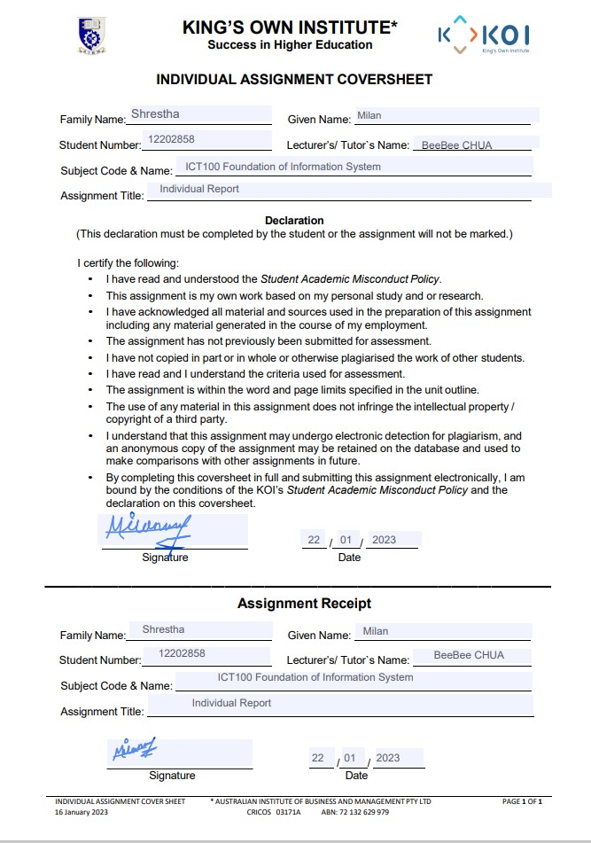

Artificial Intelligence in Innovation Milan Shrestha: 12202858

Table of Contents

1. Introduction………………………………………………………………………………………………………3
2. Discussion………………………………………………………………………………………………………….4
   1. Benefits of Artificial Intelligence………………………………………………………………….4
   2. Challenges with Artificial Intelligence……………………………………………………………6
3. Findings……………………………………………………………………………………………………………….7

3.1. A Case Study ......................................................................................................7

1. Executive Summary………………………………………………………………………………………………8
2. Reference list……………………………………………………………………………………………………….9

Artificial Intelligence in Innovation Milan Shrestha: 12202858

**Introduction:**

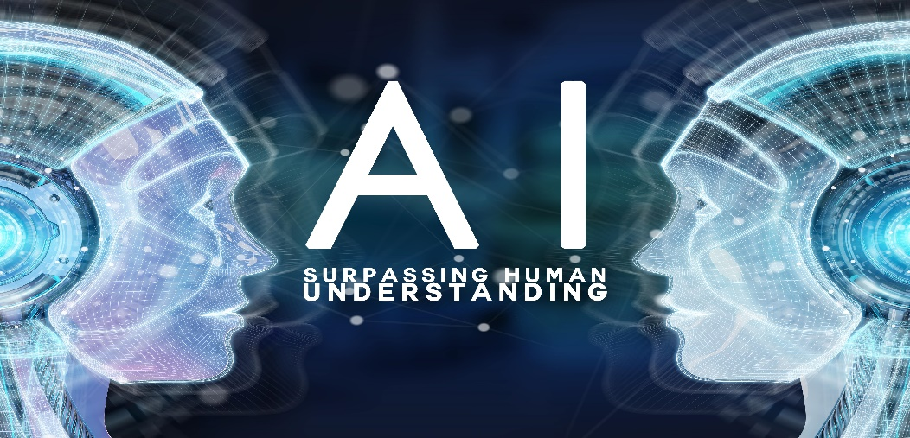

**Source:** [artificial intelligence - Bing images](https://www.bing.com/images/search?view=detailV2&ccid=TKziVGMg&id=8739A9D839973E2449D887AA0B22E3353F7DA388&thid=OIP.TKziVGMgadot4JUwINii7gHaE8&mediaurl=https%3a%2f%2ficaagencyalliance.com%2fwp-content%2fuploads%2f2019%2f01%2fArtificial-Intelligence-Growth.jpg&exph=3744&expw=5616&q=artificial+intelligence&simid=608004689057433970&FORM=IRPRST&ck=B110D1E23FE29E7EA27AB4AA9E863FB2&selectedIndex=2&ajaxhist=0&ajaxserp=0)

One of the most fascinating and amazing inventions in human history is unquestionably artificial intelligence**.** The concept of artificial intelligence dates back to the 1950s; however, John McCarthy first used the phrase "artificial intelligence" back in 1956. Since then, scientists have been actively working to make a machine that can perform tasks that are thought to require human intelligence. What exactly does AI imply? Artificial intelligence (AI) is the ability of a computer or computer-controlled robot to carry out actions that are typically performed by intelligent beings. To be more precise, it is a set of algorithms with a certain set of rules that are implemented in machines to carry out operations that actually require human intelligence.

What is the significance of AI? It's simple, to innovate new things and make our lives easier. Artificial intelligence (AI) is transforming every aspect of society at the individual, organizational, and societal levels (Brynjolfsson & McAfee, 2017). AI is in its development phase and is evolving day by day. It has a wide range of implications and can be integrated into various fields like, business, banking and retail, gaming, robotics, health sectors, etc. In fact, there is not a single field that is not affected by AI. Interestingly, researchers have already developed software that uses Darwinian evolution ideas, such as "survival of the fittest," to construct AI algorithms that improve from generation to generation without the need for human intervention. Similarly, the fact that AI is already being applied in domains like medical diagnosis, language translation, computer design, and voice or handwriting recognition emphasises how important it is. Considering its significance, many countries are already working on it, i.e., the U.S.A., China, and India being the top three nations in AI research output.

 .

Artificial Intelligence in Innovation Milan Shrestha: 12202858

**Discussion:**

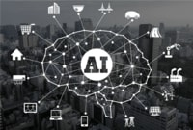

Source:[https://www.cloudcomputing.id/berita/indonesia-masuki-persaingan-ai-dunia](https://www.cloudcomputing.id/berita/indonesia-masuki-persaingan-ai-dunia%20%20%20%20%20%20%20%20%20)

**Benefits of Artificial intelligence:**

Scientists appeared to see AI as a medium to explore various possibilities rather than challenges from the time the concept was introduced. What is more interesting is that companies like Alibaba and Amazon are already using artificial intelligence to deliver top-tier goods and services which signifies its importance. Both Alibaba and Amazon use AI in data mining to provide consumers with useful product recommendations. The "E-commerce Brain" software, created by Alibaba, analyses real-time online data to forecast consumer demands. Through artificial intelligence (AI), the models are updated continuously for each user to consider purchase history, browsing history, and online activity. Furthermore, Amazon and Alibaba have integrated artificial intelligence into their supply chains, which predict logistics, delivery dates, and stock levels per purchase. All these features help customers in buying any product online with ease. Therefore, there is no doubt, all these factors are responsible for the success and reputation of these two e-commerce giants. (<https://infotech.report/articles/5-ways-amazon-and-alibaba-use-ai-and-data-mining-to-increase-e-commerce-sales>). Other example of AI technology can be seen in mobile, health and robotics industry too. The use of various AI features in Apple products, such as Face ID, the translate app, Sound recognition, and others, is their trademark and a key factor in their success. Apple is the market leader in the production of various electronic devices, including the iPhone, Mac, iPad, iPod, Apple Watch, and others. In robotics industry, scientists are trying to build an AI robot which will have the intelligence and capacity to perform human task independently. As mentioned above, since AI is being used in various fields and has been proven to be beneficial for mankind, it is not wrong to say our future will heavily rely on AI.

Artificial Intelligence in Innovation Milan Shrestha: 12202858

**Challenges with Artificial intelligence**

**The topic of whether AI is actually beneficial to humans has arisen while debating and applauding the significance of AI and its exponential growth over the past few years. Since AI has the capability to think and act on its own, people and scientists alike are filled with apprehension and scepticism about its future.** According to Kurzweil (2006), when this happens, computers will be able to grow exponentially in comparison with themselves and reproduce themselves, and their intelligence will be billions of times faster than humans (p. 156). In 60 years, AI will pose a severe threat to humanity, predicts Bostrom (2016). Thus it has become a topic of concern regarding the future of AI and create a sense of fear in general public. Other challenges associated with AI are ethical problems, ethical difficulties are caused primarily by the collection, analysis and processing of citizens ' digital data-big data, social data and personal data. Moreover, the problem of ensuring the security of confidential information is one of the key for all subjects of the digital economy, including the problem of cybersecurity using AI (Wilner, 2018, pp. 308-316). These are the some of the concerns and challenges with AI.

Artificial Intelligence in Innovation Milan Shrestha: 12202858

**Findings**

**A case study:**

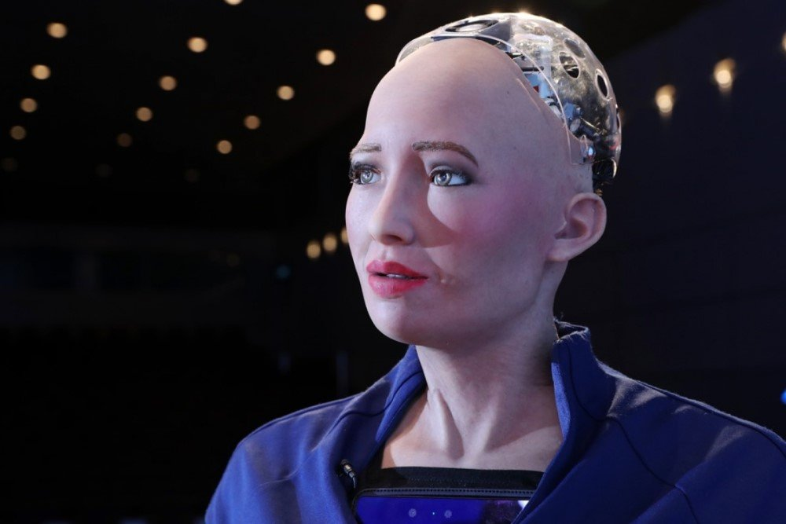

**Fig: Sophia a Humanoid Robot**

**Source:**[**https://www.unite.ai/is-hansons-robotics-sophia-robot-using-ai-or-is-it-a-marketing-stunt/**](https://www.unite.ai/is-hansons-robotics-sophia-robot-using-ai-or-is-it-a-marketing-stunt/)

This case study will primarily focus on the implication of AI technology in robotics and will highlight its results and future possibilities. Sophia is the most recent humanoid AI robot made with cutting-edge robotic technology. The humanoid "Sophia" was developed by Dr. David Hanson, who founded Hanson Robotics and serves as its CEO[2]. Sophia the humanoid was activated on April 19, 2015, and she made her first public appearance in March 2016 [3]. (<https://www.smec.ac.in/assets/images/committee/research/1718/539.Case%20Study%20of%20Sophia%20%E2%80%93%20The%20Humanoid%20Robot.pdf>). Sophia is capable of imitating human gestures and facial expressions and can answer certain questions and engage in simple conversations. It was only possible by the use of various AI features like, symbolic AI, neural networks, expert systems, machine perception, conversational natural language processing, adaptive motor control, and cognitive architecture.

Artificial Intelligence in Innovation Milan Shrestha: 12202858

This is an astonishing achievement in the human history, and create enormous possibilities for the future to create more advanced robots which are capable of handling complex issues by their own.

**Executive Summary**:

In a nutshell, the development of artificial intelligence (AI) has greatly increased potential in the fields of business, research, and health, giving them a substantial advantage. Various companies like Alibaba and Amazon are already using AI in their business in several ways and are proving to be effective. The use of AI is unlimited, however, if people become more dependent on AI, a number of issues and concerns will emerge which could impede the advancement of AI. But if we can solve all the issues with AI, it has lots of merits and holds the capability to change the future.

Artificial Intelligence in Innovation Milan Shrestha: 122028

**References:**

Khisamova et al (2019), Artificial Intelligence and Problems of Ensuring Cyber Security; International Journal of Cyber Criminology, Vol 13)

Available from:<https://www.proquest.com/docview/2384582919?pq-origsite=gscholar&fromopenview> [Accessed on: 22/01/2023]